1. Login to AWS web console

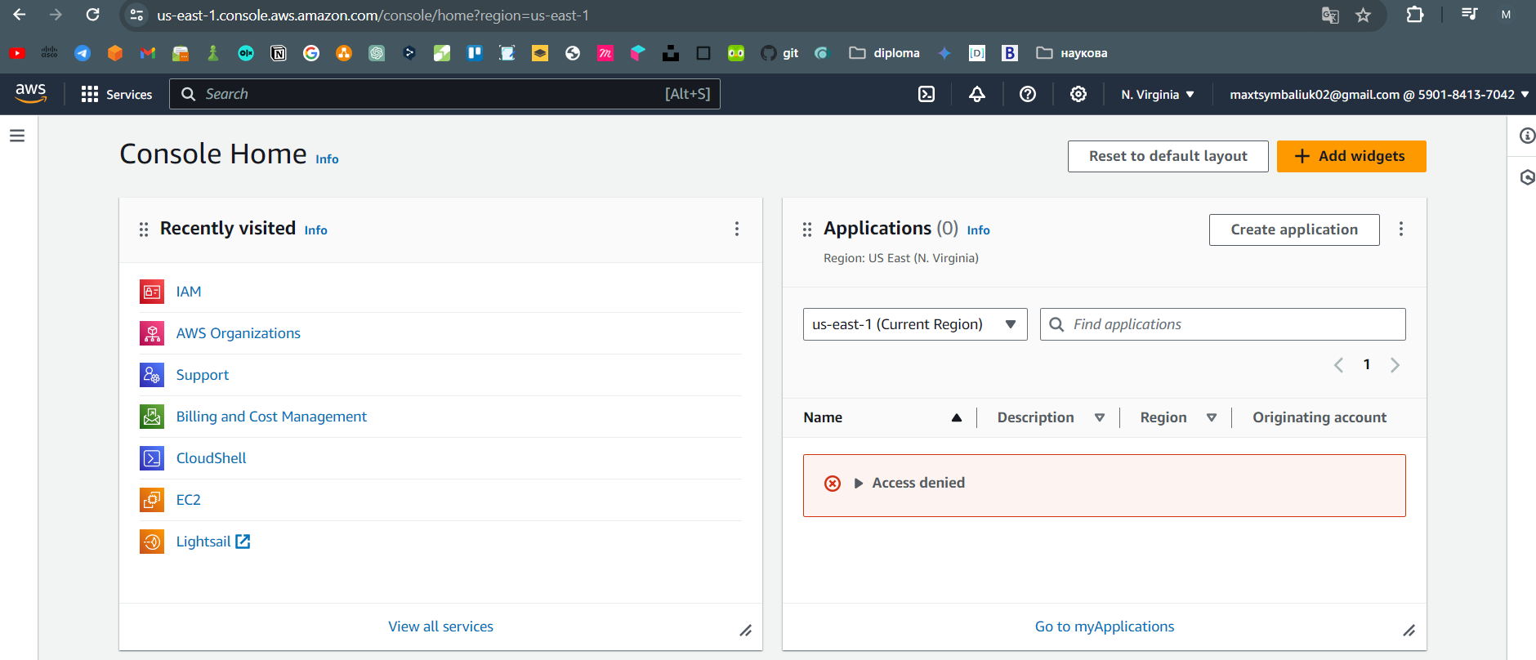

1. Create test ec2 instance with type t3.micro based on Ubuntu. Use public ip

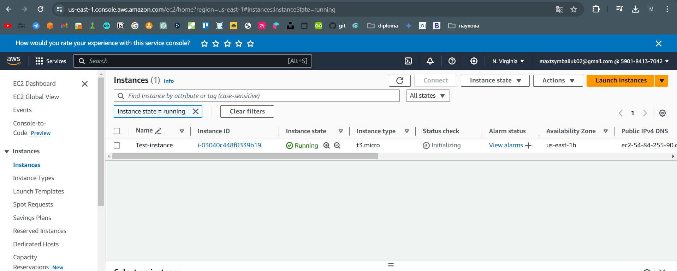

1. Connect to ec2 via SSH. Check that it works

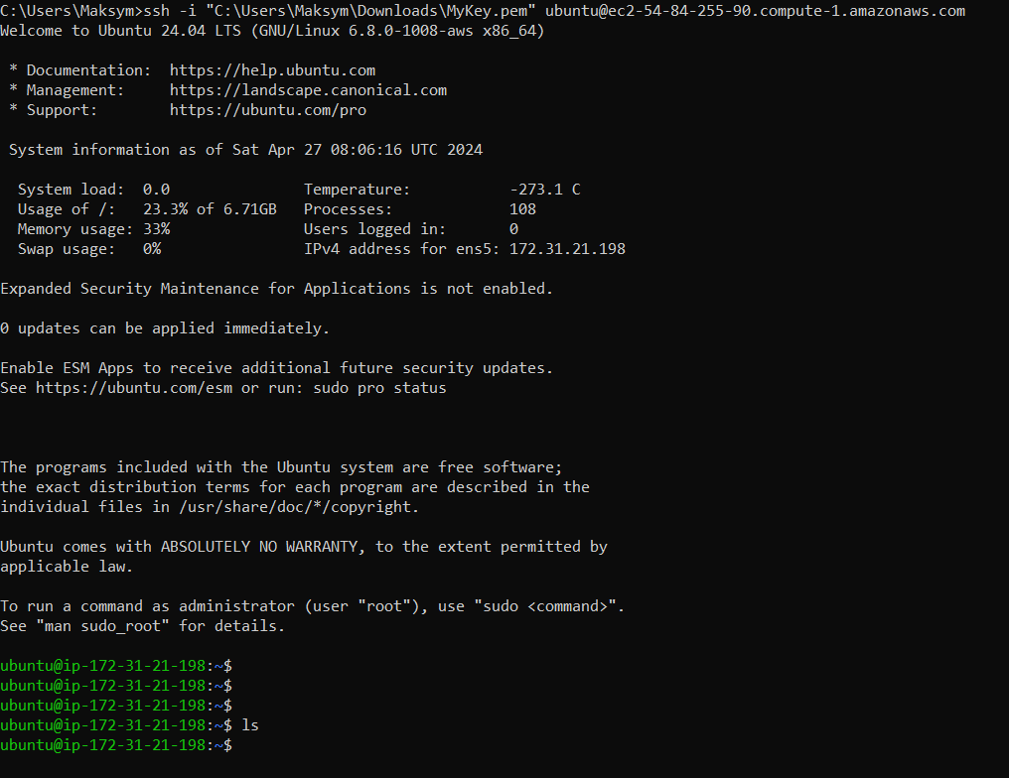

1. Destroy test ec2

